ACCOMPLISHMENT REPORT
IT 307 & 307L – Event-Driven Programming
Month: Novembers – Year: 2025
School Year: 2025 – 2026 1st Semester

DATE | ACCOMPLISHMENT | REMARKS  (Progress and deviations from the plan) *
November 11 – 14, 2025 | Lecture Accomplishments:  - Revisited multi-page PHP application structure and secure file handling from October (uploads/downloads, validation, MIME checking, filename sanitization) as a springboard for deeper Module 3 integration.  - Discussed how sessions and cookies support user tracking and state management in event-driven web workflows (e.g., remembering logged-in users or last actions across pages).  - Introduced the idea of using APIs alongside file-based workflows (e.g., combining uploaded data with API-provided information), focusing on conceptual understanding rather than full implementation.  - Highlighted secure coding and error-handling principles specific to multi-page and file-based systems (validation of inputs, suppression of unsafe error messages, logging errors to files or tables instead of showing them to users).  Laboratory Accomplishments:  - Guided students in enhancing their existing multi-page PHP applications by refining navigation between pages (using GET, POST, sessions, and cookies) and organizing shared layouts (headers/footers).  - Asked students to review and update their upload/download features, enforcing file size/type limits and improving error messages shown to end-users.  - Conducted a debugging-focused lab activity on common multi-page/file-handling errors (broken links, wrong paths, missing permissions, invalid file uploads).  - Required students to submit updated versions of their Module 3 lab projects with a short note describing what they improved in terms of security, validation, and user feedback. | Accomplished  (Module 3 work on multi-page applications and file handling was reinforced and improved, preparing the class for hands-on API calls and testing in the following weeks.)
November 17 – 20, 2025 | Lecture Accomplishments:  - Introduced API integration concepts for event-driven web applications: HTTP methods (GET/POST), endpoints, query parameters, and typical JSON responses.  - Explained how client-side JavaScript can trigger asynchronous events (e.g., using fetch()/AJAX) and update parts of the page without a full reload, connecting this to the event-driven paradigm.  - Discussed basic authentication and security considerations when consuming APIs (API keys, tokens, rate limits, and safe storage of credentials).  - Outlined the scope of Module 3 for the remainder of the term, clarifying that:  Laboratory Accomplishments [EXAMINATION WEEK]:  - Guided students through a step-by-step lab exercise where a simple public API was called from PHP or JavaScript, and the JSON response was displayed in a basic HTML page (e.g., listing items or showing a simple status).  - Implemented simple asynchronous interactions, where a button click/event triggered an API request and updated a result area on the page (event-driven workflow).  - Encouraged students to log success and error events (e.g., saving error messages or response status to a file or simple log table) to connect API usage with Module 3 testing and debugging outcomes.  - Collected initial API-integration lab outputs as draft implementations, with the understanding that more sophisticated handling (loading indicators, richer UI, combined file/API workflows) will be completed in December. | Accomplished  (Students were introduced to basic API integration and asynchronous event handling patterns, with foundational implementations that will be expanded and hardened in December.)
November 25 – 27, 2025 | Lecture Accomplishments:  - Discussed testing and debugging strategies specific to multi-page and API-integrated applications:  - testing form flows and navigation,  - testing file upload/download scenarios,  - testing API calls and handling failed responses/timeouts.  - Introduced simple test case documentation (listing inputs, expected outputs, and actual results) to promote systematic checking of event-driven applications.  - Emphasized ethical and user-centered considerations such as clear error messages, privacy of logged information, and avoiding exposure of API keys and sensitive data.  - Presented the outline of the upcoming December activities: finalizing an integrated mini-project (multi-page + file handling + basic API calls), consolidation of debugging practices, and the final-term assessment.  Laboratory Accomplishments:  - Conducted a lab-based testing activity where students created and executed test cases for their current Module 3 applications (navigation, uploads/downloads, simple API calls).  - Instructed students to use logs and on-screen messages to identify and fix issues (validation errors, incorrect routes, unexpected API responses, missing error handling).  - Asked students to prepare an initial integrated mini-project draft, combining at least: multi-page navigation, one file operation (upload or download), and one simple API call, to be refined and finalized in December.  - Collected test case sheets, debug logs/notes, and screenshots of running systems as proof/evidence of Module 3 progress at the end of November. | Accomplished  (Initial integrated mini-project drafts and testing/debugging activities were completed; full polishing of API integration, asynchronous patterns, and final assessment are intentionally reserved for December.)

*Provide relevant documentation such as pictures, summary reports, etc.

Prepared by: Approved:

JUNNIE RYH M. SUMACOT SHERWIN G. CADAY, PhD.
Instructor Program Chair

PROOF/EVIDENCE OF REPORTED ACCOMPLISHMENTS
IT 307 & 307L – Event-Driven Programming
Month: November – Year: 2025
School Year: 2025 – 2026 1st Semester

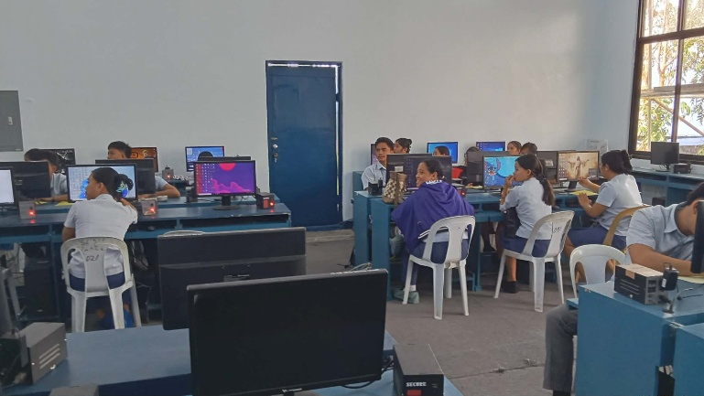
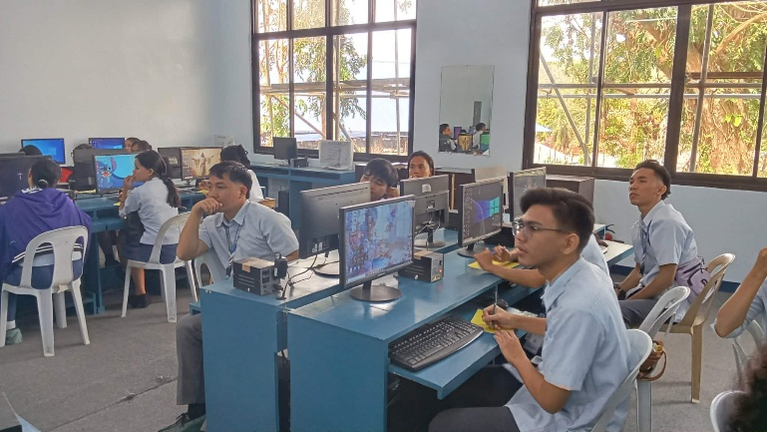

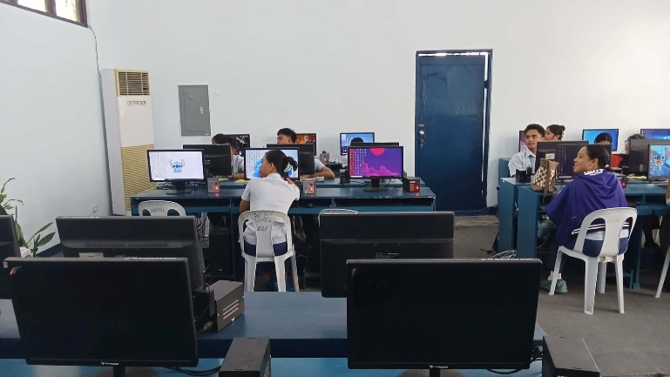
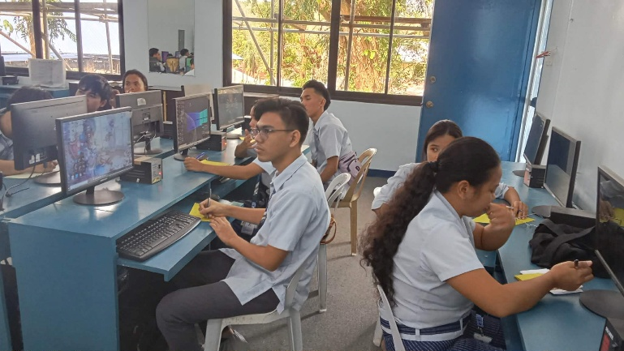

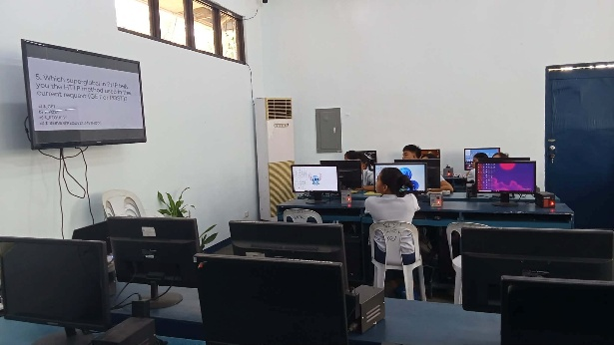
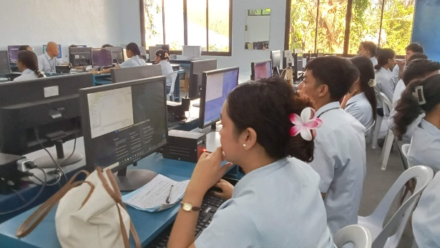

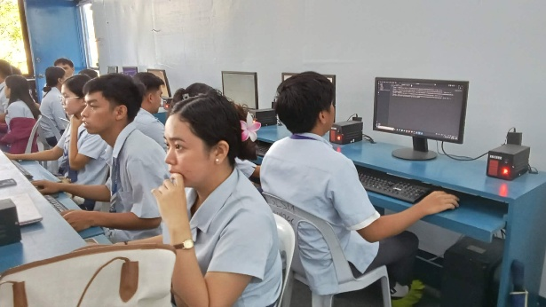
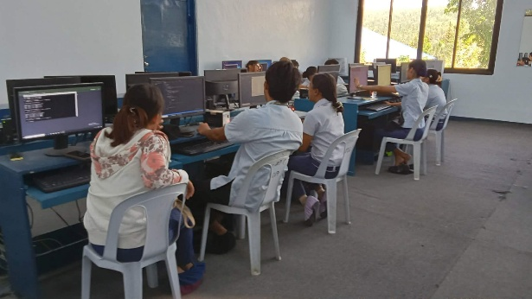

Prepared by: Approved:

JUNNIE RYH M. SUMACOT SHERWIN G. CADAY, PhD.
Instructor Program Chair

